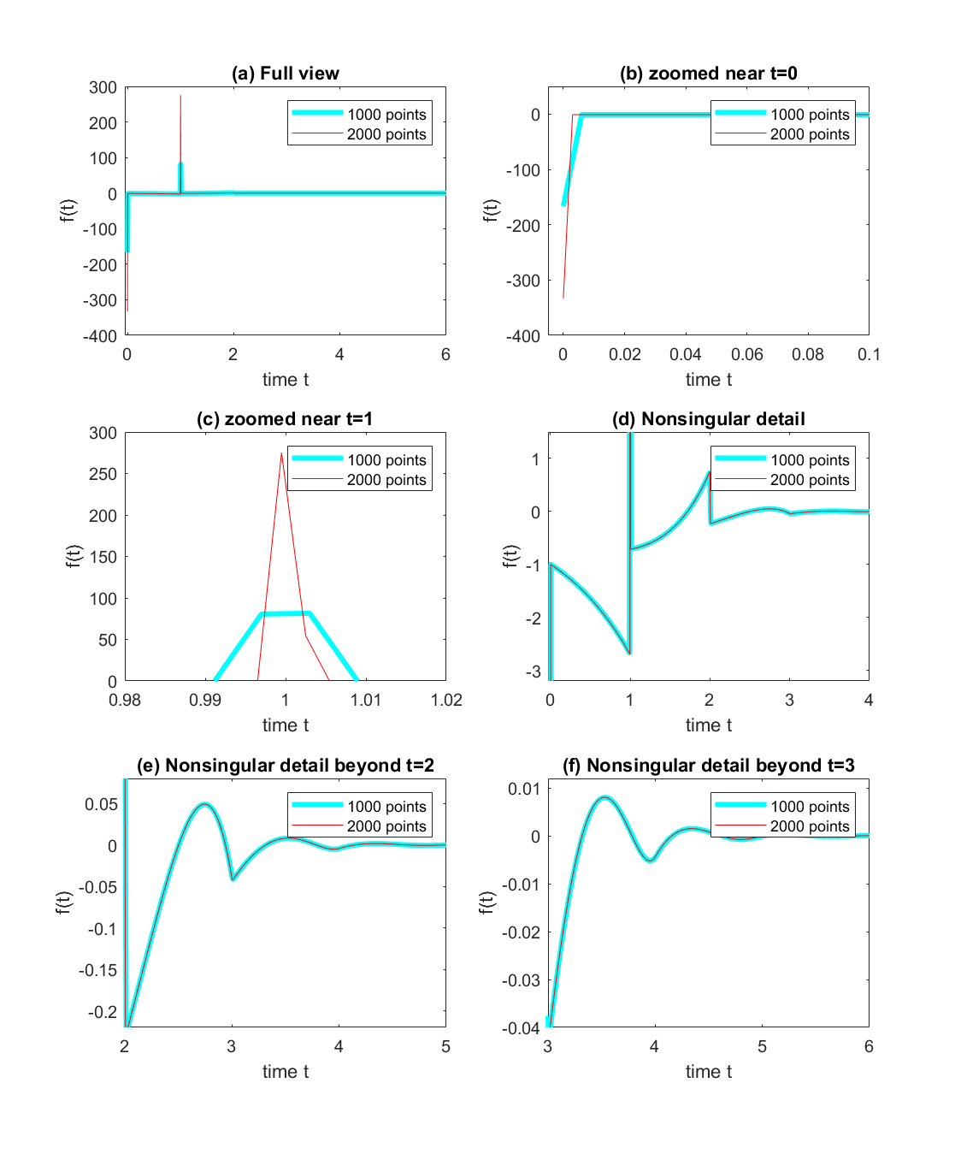

Figure 1

The polynomials were obtained using Matlab’s polyfit function. p1 represents polynomial in the interval [0,1] and similarly for other intervals respectively. The following are the polynomials obtained.

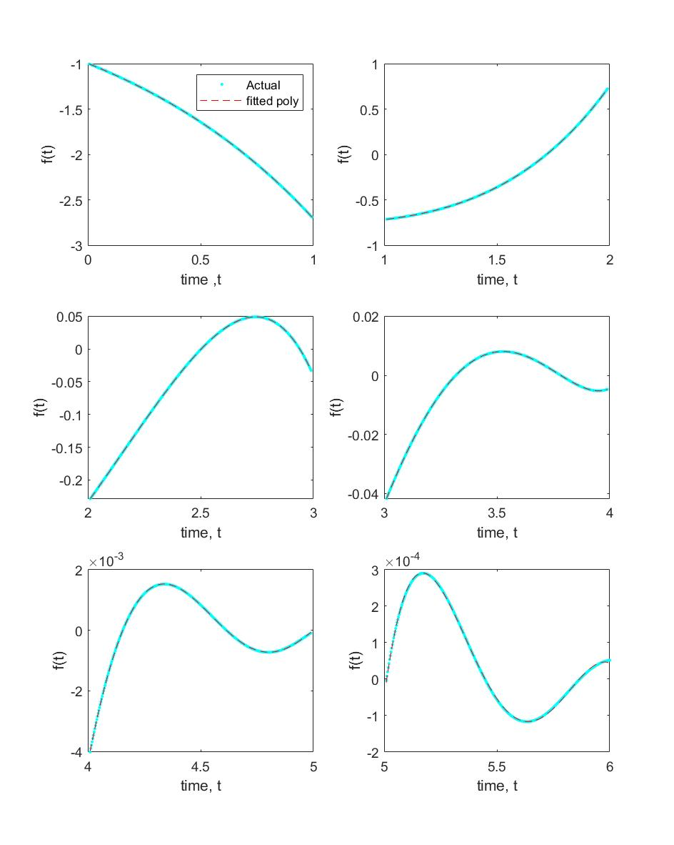  
Figure 2- Actual and fitted polynomials

The discrete delayed feedbacks are only considered at t=0 and t=1, distributed delayed feedback are considered using integrals. The following DDE is obtained-

Then substituting *x(t)* = *eλt,* the following characteristic equation is obtained-